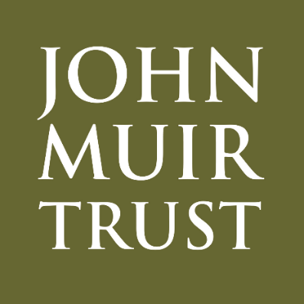

Management Plan for the Trusts work within the Thirlmere Catchment
Prepared in 2023. Updated 2024
© Lisa Bergerud
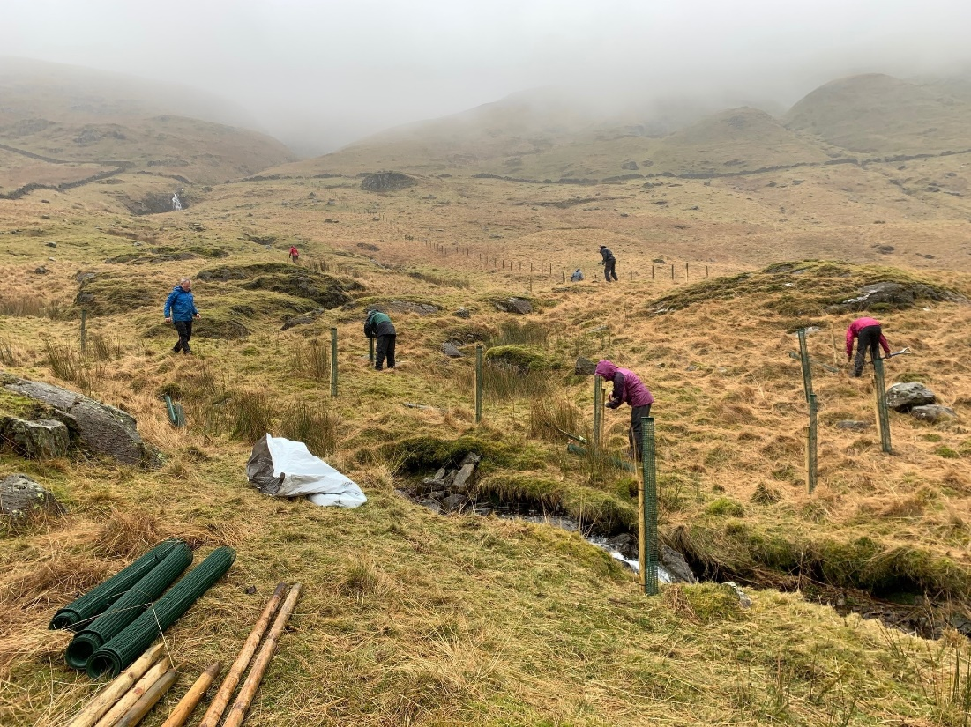
Approximate Area: 4322 hectares
National Grid Reference: NY 34243 15107 (summit)
For the most recent information on our work at Thirlmere, visit https://www.johnmuirtrust.org/whats-new/news/1403-more-trees-planted-at-thirlmere

Contents
1 Introduction 3
2 Glenridding Common 3
3 Our Ambitions 4
3.1 Our Vision 4
3.2 Freedom for nature to repair itself 4
3.2.1 Arctic alpine and woodland 4
3.2.2 Monitoring nature’s recovery 5
3.3 An individual’s freedom to enjoy the benefit of wild places 6
3.3.1 Access 6
3.3.2 Visitor infrastructure 6
3.4 The community’s freedom to thrive in wild places 6
3.4.1 Partnerships 7
3.4.2 Volunteering 7
3.4.3 Outdoor learning 8
3.4.4 Public events 8
3.4.5 Consultation 8
4 Appendices 9

1 Introduction
This is a living document that outlines our management aspirations for Thirlmere. We are working with United Utilities, Cumbria Wildlife Trust and Natural England as part of the Thirlmere Resilience Partnership. This partnership aims to increase carbon sequestration, improve water quality and increase biodiversity within the catchment while engaging the local community with our work. The farm at West Head also plays a key role in delivering these objectives.

2 Thirlmere
The Thirlmere reservoir and surrounding catchment is an area of exceptional beauty and a popular destination for walkers, comprising around 4322 Hectares of land, including the summit of Ullscalf (726 m). It sits within the Lake District High Fells Special Area of Conservation. Please note the approximate management area excludes the reservoir itself.
The Trust entered the partnership in 2020, committing to delivering tree planting schemes in the Wythburn Valley in the spring of 2022 and 2023. As of July 2023, the Trust recruited a Thirlmere Resilience Project Officer. This role will allow the Trust to deliver much of the work outlined in the partnership’s MoU. We work with the partners to protect and enhance the ecosystem while respecting the area’s cultural traditions - recognising this is a key aspect of the Lake District World Heritage Site status.

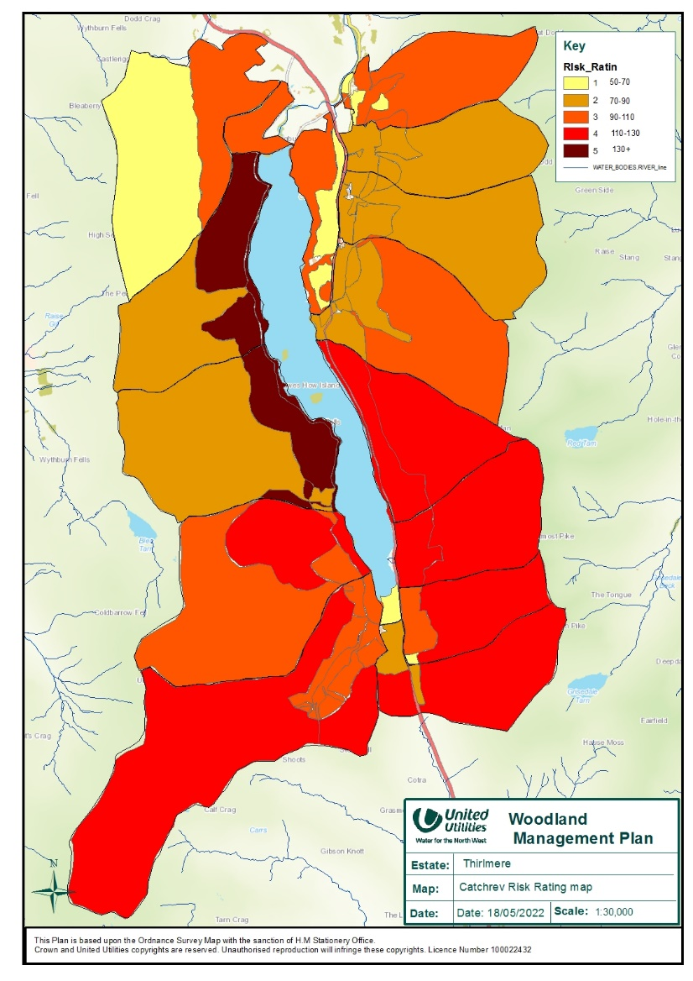

3 Our Ambitions

3.1 Our Vision
The purpose of the John Muir Trust is to conserve, protect and restore wild places for the benefit of all. Our vision is a world where wild places are valued for present and future generations. One of the ways we work towards this is by taking on stewardship of wild places and working with the community to protect and repair them.
The Trusts notable involvement in the Thirlmere catchment is listed below.

- Together with CWT staff, the Trust conducted feasibility surveys to identify what could be achieved as part of the partnership.
- The Trust has delivered 2 joint volunteer work parties with Fix the Fells on a path up to Helvellyn summit.
- The Cumbria land team have assisted with a biannual deer census in the southern part of the catchment. These counts help the landowner deliver better deer management.
- Delivered 2 volunteer planting programmes in the Wythburn valley. These sessions engaged 125 local people with the area and allowed us to plant over 3000 trees over 2 years.
- The Trust is leading on a project to establish a tree nursery at West Head Farm.

Looking ahead, John Muir Trust’s vision for protecting, repairing and enhancing the wild places at Thirlmere is focussed on helping nature, people and communities. To achieve our vision, our exemplary management approach is based on the priorities outlined in the sections below.
We are working to increase native woodland cover across the project area. The local community is a key part of this work from a stakeholder engagement perspective but also to deliver aspects of this work. We are also looking to improve populations on montane plants in key areas. The Trust will also work with any of the other partners on mutual targets, even if not leading on that piece of work.

3.2 Freedom for nature to repair itself.
Our objective is to restore a mosaic of habitats which supports a diverse range of species, working alongside our neighbours, partners and the local community to create a sustainable and functional ecosystem.
The Thirlmere catchment consists of a wide range of habitats. Conifer plantations make up a large proportion of the land holding as well as open fellside/common land. This common land is mainly comprised of acid grassland and peatland. Note the in-hand forestry has its own management plan that sits within UU. There are small sections of cluster planting in mesh cages across the common although many of these have failed.
There are some areas of high-altitude crags home to rare flora. Aspen, Eared Willow and Wood Cranesbill grow on inaccessible ledges on Rake Crag, Ash Crag and Comb Crag.

3.2.1 Woodland and other Flora
Objective WH: Increase woodland cover in the Thirlmere catchment.
Following on from 2 years of tree planting in the Wythburn Valley, the Trust will increase the number of native broadleaf trees around the Thirlmere catchment.
Both Raise Beck and Wythburn have extensive sections of stock fencing on either side of the watercourse. These areas have been identified as key places to increase woodland cover within the catchment. Over 3000 trees have already been planted with an annual target of 1000 going forward. as the project develops, we hope to increase the numbers of trees planted. We are exploring other areas to increase woodland cover through more fencing.
As part of a previous Sustainable Catchment Asset Management Plan at United Utilities, thousands of trees have been planted in clusters on the open fell. Due to several factors, many of these have been unsuccessful. These cages have been surveyed and with the help of volunteers, the Trust will beat up and restock many of these mesh cage.

Objective WH: Increase populations of other flowering plants in the Thirlmere catchment.
Restoring populations of wildflowers/other plants is a key objective for the Trust. Following on from our work at Glenridding, we will work with a team of local volunteer growers as well as Natural England to propagate and plant targeted species. These will bolster existing populations and start new plant communities where appropriate.
Both the above objectives, a tree nursery at west head farm is fundamental to achieving these goals.

Activity | Timeline
Design and deliver a tree planting programme in Raise Beck and Wythburn | 2023-25
Plant out species of rare flora to reinforce small populations and start new ones | 2023 -25
Design and deliver a programme of work to beat up and restock some areas of mesh cage planting. | 2023-25

3.2.2 Monitoring nature’s recovery
Objective MH: Our sites show habitat regeneration as a result of our management approach.
Annual monitoring of key species is undertaken. Most of the monitoring is done in a standardised format.
Impact | How we monitor them | Timeline
To assess changes in the level of grazing, including browsing damage | Monitor planted trees in Wythburn.  Catchment condition assessment. | Annual
To assess changes in the habitat, particularly the impact of woodland expansion | Breeding birds are surveyed using repeatable methodology for Breeding Bird Surveys (BBS).  Fixed point photography  Moth surveys | Annual
To assess for presence of rare species | Where feasible, contract ecologists/specialists to survey for specific species groups. This will help us better understand the special qualities of the site. | Ad hoc

3.3 An individual’s freedom to enjoy the benefit of wild places.

We believe people should have access to wild places and the knowledge and awareness of how to best connect with the natural environment and the actions they can take to protect it. This connection builds value and those who value wild places are more likely to care for and take action to protect them.
The John Muir Trust wants to inspire people and communities to experience and feel empowered to advocate for the benefits of wild places, to be able to influence government and land managers to protect wild places. To do this, we will work with partners to maintain access to the Thirlmere area and contribute to keep the sites safe, tidy, and free from pollution.

3.3.1 Access
Objective AH: To support public access by monitoring and maintaining the wider path network as required.
The eastern side of Thirlmere has a large footfall from people ascending Helvellyn. This path is largely in good condition, but improvements can be made where appropriate. The Fix the Fells partnership has a programme of work across the Lake District to maintain and improve fell paths. In alignment with their work programme, the Trust can organise work parties to complete minor works and clear fell drains. The Trust may also employ 2 local contractors to complete minor skilled works.

Activity | Timeline
Liaise with partners to jointly manage path network. | 2023 -25

3.3.2 Visitor infrastructure
Objective IH: To provide facilities and information to help people enjoy and explore wild places responsibly.
There may be opportunity for some interpretation in popular car parks for people to learn about the site.

The community’s freedom to thrive in wild places.
Thriving communities are core to the Trust’s ethos and we work in partnership to enable communities to protect the wild places important to them. We understand that people and communities are not something distinct from nature but that they are interdependent, and we aim to enable communities to get the best from their wild places and thrive alongside the nature that lives there. We can only realise this with the help of communities who can care for wild places.

3.4.1 Partnerships
Objective PH: To work with other groups and organisations towards common aims and align our management plans to create better connectivity of habitats.
At Thirlmere, the Trust work in partnership with United Utilities, Cumbria Wildlife Trust and Natural England to deliver landscape-scale ecological restoration to improve the resilience of the whole Thirlmere catchment and improve raw water supply. Our work benefits people and wildlife by implementing natural solutions to the climate and biodiversity crises. We signed a Memorandum of Understanding in 2021. This project allows the Trust to work across a greater area of the Helvellyn massif and increase our impact.
The Trust also engages with the Cumbria Nature Recovery Group, who are aiming to undertake landscape-scale nature restoration in the National Park.
Activity | Timeline
Deliver the Thirlmere Resilience Project, including creating a plan for delivery of natural solutions to flooding and improvements to the environment at Helvellyn, working with volunteers. | 2023-2025
Attend meetings of the Cumbria Nature Recovery Group | 2023 onwards

3.4.2 Volunteering
Objective VH: To help us co-deliver our Property Management Plan and support people to feel connected to the site.
Volunteering is a key part of the Trusts work at Thirlmere. We will offer regular work parties where volunteers will become better connected to the land and deliver rewarding conservation tasks.
We have a very successful community group growing Arctic-alpines and montane shrubs to reinforce populations at Thirlmere. The group is supported by volunteer qualified climbers, who aid with planting on steep slopes. This activity has attracted new volunteers, supported directly with staff time from Natural England. This activity raises the profile of the Trust, supports the local community, grows the plants we need to help with site restoration, and importantly, connects local people with wild places on their doorstep. The volunteers also gain a greater understanding of the work at Thirlmere and can be advocates in their neighbourhood.
As part of the Thirlmere Resilience Partnership, a tree nursery will be created at West Head Farm. This will rely heavily on volunteer support.

Activity | Timeline
Continue to arrange work parties for volunteers that link with the aims of the Property Management Plan | 2023 -25
Support the Community Grower’s Group | 2023 - 25
Provide volunteering opportunities in Thirlmere on behalf of the Thirlmere Resilience Project | 2023 - 25

3.4.3 Outdoor learning
Objective LH: To provide inspiring outdoor learning opportunities for people to connect with wild places and learn about our work to conserve, protect and repair wild places.
The Trust seeks to engage with a range of groups in and around the Lake District. The Trust has and will continue to provide valuable learning opportunities on the Thirlmere estate. Key target groups are local schools, colleges, young ranger groups, and university groups. These groups can visit the site, take part in, and learn about the work we are doing. There is scope to visit groups at their school/college.
Activity | Timeline
Tree planting with various groups | 2023 – 25
Landscape Leader Training | 2023 – 25
Provide talks to local groups | 2023 – 25
Facilitate site visits for groups | 2023 - 25

3.4.4 Public events
Objective EH: To allow people to access wild places and share our work with the wider community.
The Trust will host events centred around the Thirlmere Resilience Partnership. In accordance with membership team and other partners, we will provide public events to engage people with the land and the project.
The Trust also attends local events such as Kendal and Keswick Mountain Festivals.
Activity | Timeline
Attend Kendal and Keswick Mountain Festivals | 2023 - 25

3.4.5 Consultation
Objective CH: To work with communities of interested individuals and groups and incorporate their thoughts and ideas into our management plan.
Consultation is a key part of land management and the decision-making process. This management plan lays out the vision and broadly details our objectives for the estate. The Trust will engage with and undertake consultation with both the local community and stakeholders on specific aspects of land management as they develop.
Activity | Timeline
To consult on our activities as we develop our plans | 2023 - 25

4 Appendices

A: Habitat Monitoring Plan
B: Engagement and Evaluation Plan

